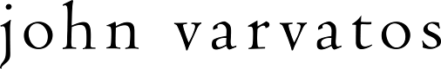

JOHN VARVATOS ANNOUNCES NICK JONAS COLLABORATION

Nick Jonas is now the face of the Spring/Summer 2018 Campaign

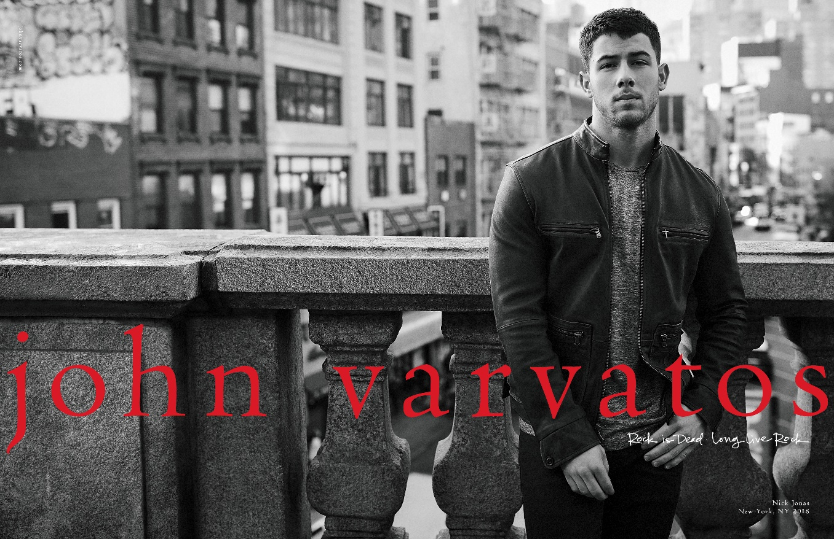

John Varvatos is proud to announce an exciting new partnership with [Nick Jonas](https://www.johnvarvatos.com/jv-x-nj/). The collaboration begins with Spring/Summer 2018. As part of this collaboration, John and Nick have designed a unique limited-edition capsule collection, in tandem with Nick becoming the new face of the brand. The two have developed a rich organic friendship born from a mutual, deep-rooted affinity for music, fashion, pop culture and philanthropy, inspiring an ongoing relationship.

“The process in working with Nick is amazing.” Varvatos said, “He's a musician, he's an artist, he's an actor, he's intrigued by everything in the world and I had a real connection with that. It's inspiring to be around someone who is not only connected with the trade that they do, but also with what's happening in the environment around him, and how that connects to what we do with style… We're working together on a number of things, first he's going be the face of our campaign, and then we've collaborated on a series of items for the spring season, and we had a great time doing it together.”

The excitement is echoed by Nick Jonas, stating “We sat down at dinner and I knew right away this was going to be a great friend of mine, - I think it made sense to both of us. The human connection was so real because the friendship evolved in such a natural way, the next step was trying to make something great together. Beyond just fashion and music and the tie in there, we're thinking big picture about how do we influence the world in some way…”

The capsule itself personifies the rock n’ roll spirit inherent to the John Varvatos brand, infused with the energy and style of Nick Jonas. From knitwear to leather jackets, each piece carries its own identity while fully comprehending the duality of the modern man’s day-to-day. For the first time in the brand’s history, it will feature a new joint label; [JV x NJ](https://www.johnvarvatos.com/jv-x-nj/).

“This collaboration is unique to us “quoted John, “We've never done another collaboration with any artist, any individual, on the product, the design, the aesthetic of the brand. I look forward to doing many more things with Nick in the future.”

At the heart of the collaboration is Detroit. Steeped in rich musical history and serving as the backdrop to John Varvatos’ early life, the city has come to symbolize a hub of art and culture that resonates deeply with Nick Jonas as well.

“In our first conversation, we were talking about Detroit” Nick said, “I've had the chance to play some really iconic music venues there and I love the city, I love the people, and so we thought "Let's take a great American city and show some love, pay respect to so many musical icons and just great men and women that have come out of there."

The campaign follows 25 seasons produced by YARD and photographed by Danny Clinch, all of which underscore the brand’s affinity for creative vanguards and standout style-makers. Past collaborators include Machine Gun Kelly, Vintage Trouble, Hozier, Ziggy and Stephen Marley, Ringo Starr, KISS, Willie Nelson, Jimmy Page and Gary Clark Jr., Paul Weller and Miles Kane, Green Day, The Roots, Dave Matthews, ZZ Top, Franz Ferdinand, Perry Farrell, Cheap Trick, Alice Cooper, Velvet Revolver, Iggy Pop, Chris Cornell, Joe Perry, Ryan Adams and Slash.

**ABOUT NICK JONAS:**

Multi-platinum, Grammy and Golden Globe nominated recording artist, actor, and award winning songwriter, Nick Jonas released his self-titled debut album in November 2014. The critically-acclaimed album included the double-platinum and #1 U.S. radio hit, “Jealous” and his sultry chart-climbing radio single, “Chains.” A recipient of the Songwriters Hall of Fame's prestigious Hal David Starlight Award, Jonas released his sophomore solo album ‘Last Year Was Complicated’ in June 2016. The album, which included the platinum hit "Close" featuring Tove Lo, debuted as the #1 selling album of the week. In 2017, Nick released a new single “Find You” off of his upcoming album. Jonas also co-wrote an original song titled “Home” for the movie FERDINAND, released by FOX Animation. The song was nominated for 2018 Golden Globe in the category of “Best Original Song.” As an actor, Jonas garnered unanimous critical praise for his lead role in the 2016 Sundance Film Festival favorite GOAT. He also appeared in a guest-starring role in the Fox's horror-comedy series, "Scream Queens." Jonas starred in the gritty television show "Kingdom," a mixed martial arts drama that premiered in the fall of 2014. Jonas can currently be seen alongside Dwayne Johnson, Kevin Hart, and Jack Black in JUMANJI: WELCOME TO THE JUNGLE, Sony’s reimagining of 1995’s JUMANJI. The film passed over 650 million worldwide in box office sales within its first month. Jonas most recently completed production on Lionsgate's post-apocalyptic thriller, CHAOS WALKING, which also stars Daisy Ridley and Tom Holland, and is scheduled for release in March 2019.

**ABOUT JOHN VARVATOS:**

Launched in 2000 with a collection of tailored clothing and sportswear, John Varvatos now represents an entire men’s lifestyle that includes footwear, bags, belts, eyewear, limited edition watches, men’s fragrances, and the [John Varvatos Star USA Collection](https://www.johnvarvatos.com/star-usa-new-arrivals/).  The designer has been recognized three times by the CFDA with an American Fashion Award for New Menswear Designer (June 2000) and Menswear Designer of the Year (June 2001 and June 2005) and was honored as GQ’s “Designer of the Year” in 2007.  In October 2013, John released his first book entitled *John Varvatos: Rock in Fashion*, which documents the elements of rock style that are intrinsic in the music community. Further rooting the brand in music, John Varvatos entered into a strategic partnership with Republic Records to formally launch John Varvatos Records in February 2014.  In 2015, John received several accolades including Most Innovative at MR Magazine’s MR Awards Honoring Game Changers in the Menswear Industry, the Cultural Icon Award at the T.J. Martell Foundation's 40th Anniversary Gala, the ACE Award for Designer of the Year given by the Accessories Council, and the Fashion Cares award given by the Samuel Waxman Foundation.  In 2016, John was awarded Footwear News’ ICON Award for Social Impact for his charitable work, most notably with The Stuart House Foundation.

**ABOUT DANNY CLINCH:**

An acclaimed music photographer and documentary filmmaker, Clinch has captured some of the most recognizable names in music, including Cash, Springsteen, Dylan and Tupac, just to name a few. The organic feel and texture of his work lets the subjects breathe and the music flow. His work has appeared in such publications as Vanity Fair, Spin, Rolling Stone, GQ, Esquire, the New Yorker and the New York Times Magazine, and his photographs have appeared on hundreds of album covers.  For more information, please visit [dannyclinch.com](http://www.dannyclinch.com)

**ABOUT YARD:**

YARD is an independent creative company that turns brands into cultural beacons. We do this by working with brands at the intersection of Brains, Beauty and Bravery, each critical to the success of creating marketing that truly moves and transforms. We provide brands with a framework that helps them to tell the right story and take the right actions at the right time and in the right channel.

To download hi-res files of the John Varvatos Spring Summer 2018 ads, click [here](https://www.dropbox.com/sh/08hj1xivujene4f/AABW-JbM6V1cNyJgzrVLJbFza?dl=0)

To download the John Varvatos Spring Summer 2018 campaign video, click [here](https://youtu.be/Cd2Ue_xw1oo)

To visit the website: [www.johnvarvatos.com](http://www.johnvarvatos.com)